Official league roster - Soccer
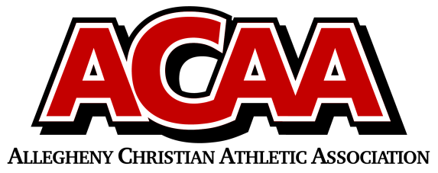

School Name: Great Commission
Team Colors: Royal Blue/White
Overall Wins ___ Losses ____ Ties ___
ACAA Wins ___ Losses ____ Ties ___
Stats: Peyton Hicks &
Marco Palazzi
Number | Name | Year | Position | Homeschool
14 | Mila Palazzi | SENIOR | MID/STR
4 | Bridgette Miller | SENIOR | Striker
11 | Alanna Rice | SENIOR | Striker | Yes
12 | Kira Suhoney | SENIOR | MID/STR
16 | Gabriella Lawson | SENIOR | DEFENSE
22 | Lily Hildebrand | JUNIOR | DEFENSE
23 | Madeline Buck | JUNIOR | DEFENSE
13 | Jaden Grove | JUNIOR | DEFENSE
9 | Olivia Fleck | JUNIOR | MIDFIELD
10 | Michelle McConnell | SOPHOMORE | MIDFIELD
88 | Kiera Wertman | SOPHOMORE | DEFENSE
27 | Kayelynn Summers | SOPHOMORE | MIDFIELD
26 | Samara Wertz | SOPHOMORE | DEFENSE
0 | Sophia Fleck | FRESHMAN | GOALIE
8 | Marlow Schorner | FRESHMAN | MID/STR | YES
15 | Alyson Miller | FRESHMAN | MIDFIELD
17 | Grace DiBiase | FRESHMAN | MIDFIELD
7 | Trinity McConnell | EIGHTH | MIDFIELD

Head Coach: Dave Long
Asst. coach: Israel Rosillo
Asst. coach: Laura Wray
Ath. Dir: Jess Suhoney
Team Managers: Sophia Hicks &
Bella Adams

Official ACAA League Team Roster. to be submitted to the scorer’s table before each game.

